|  |  |
| --- | --- |
| Student Name: Matthew Phyland | Student ID: 102119144 |
| Group Name: (None) | Date: 24/02/2020 |

You are required to complete 2 tasks for each of the following scenarios (A & B) using certain **project planning tools**.

*To be deemed competent in this task, you need to get at least 25 out of 50 marks and fulfil the hurdle requirements (see Canvas rubrics for details).*

# Scenario A

Listed below are the activities, not in any special sequence for a small project to Service a Car. Do not worry about resources for this project. You will have as many as you need.

**Note**:

* Prior to reading the directions, you have no knowledge of what is required to be serviced.
* The general Mechanical Tools and other logical equipment (too large to bring i.e. hoists etc.) are supplied.
* All other and service parts such as oil, filters and spark plugs etc. (disposable items) have to be bought.
* Most old disposable parts can be removed while new parts are being purchased.
* A car must be hoisted before the oil can be drained and the oil filter then replaced.
* Replace oil and other parts and servicing can only be done after the hoist is lowered.

## Task A1 – Activity List (10 marks)

Fill in the **activity letters** and **logical predecessors** for each activity in the blank columns of the   
**Activity List** below (do not change the information already provided to you):

|  |  |  |  |  |
| --- | --- | --- | --- | --- |
| **Letter** | **Activity** | **Abbrev Name** | **Duration** | **Predecessor** |
| A | Read All Service Directions | Read Direct. | 5 min |  |
| B | Purchase Required Parts | Purch. Equip. | 20 min | A |
| C | Hoist car | Hoist car | 5 min | A |
| D | Drain Oil | Drain Oil | 15 min | C |
| E | Replace Oil Filter | Oil Filter | 20 min | B, D |
| F | Lower Hoist | Lower Hoist | 5 min | C, E |
| G | Replace Oil | Replace Oil | 10 min | B, C, F |
| H | Replace Spark Plugs | Spark Plugs | 15 min | B, F |
| I | Replace Other Filters | Other Filters | 20 min | B, F |
| J | Test and Tune Engine | Test & Tune | 30 min | G, H, I |
| K | Check other Fluid Levels | Fluid Levels | 10 min | F |
| L | Safety Check | Safety Check | 20 min | J, K |
| M | Type up Service Bill | Service Bill | 5 min | L |

## Task A2 – W.B.S. (10 marks)

Create a **Work Breakdown Structure** (W.B.S.) for Scenario A using a digital tool.

- The W.B.S. should be in hierarchy format.

- Include all the activities on the Activity list using the “Abbrev Name” as the labels.

- Add any suitable (logical) Summary tasks.

*Paste your W.B.S. below:*

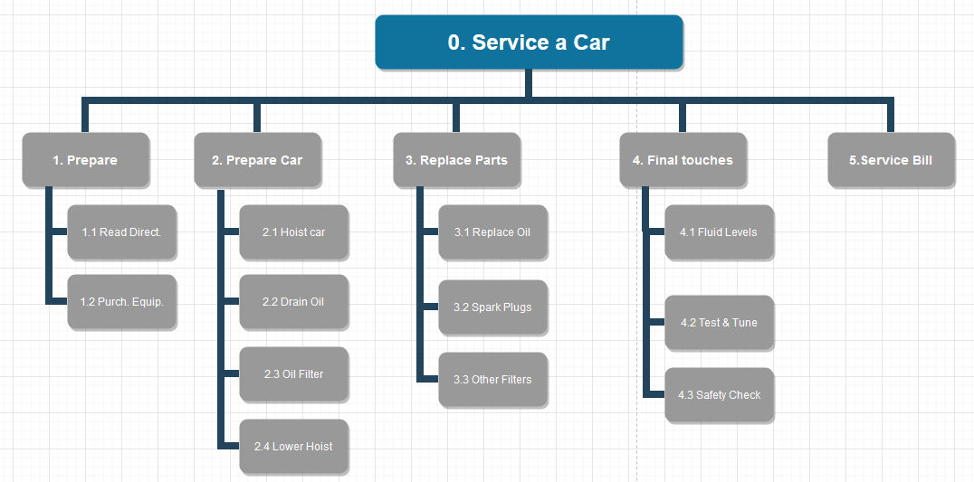

**Submission Instructions for Scenario A:**

On completion, save this file as "StudentID_Lastname.docx” (e.g. “1234567_Lewis.docx”)

Submit this file along with Scenario B’s items – see instructions on the last page.

# Scenario B

This Scenario is to paint a house. It will consist painting both the outside and inside. Provided below are the W.B.S. and Activity Listfor Scenario B.

**W.B.S.**



**Activity List**

|  |  |  |  |
| --- | --- | --- | --- |
| **Letter** | **Activity** | **Duration** | **Predecessor** |
| A | Read Directions | 10 min |  |
| B | Buy Paint | 20 min | A |
| C | Get Equip. & Access. | 15 min | A |
| D | Clean Outside | 30 min | C |
| E | Prepare Outside | 60 min | D |
| F | Undercoat Outside | 120 min | B, E |
| G | Topcoat Outside | 120 min | F |
| H | Clean Inside | 40 min | C |
| I | Mask Windows | 20 min | H |
| J | Undercoat Ceilings | 90 min | B, H |
| K | Undercoat Walls | 120 min | B, I |
| L | Topcoat Ceilings | 90 min | J |
| M | Topcoat Walls | 120 min | K |
| N | Remove Masking | 10 min | M |
| O | Clean Equipment | 15 min | G, L, N |
| P | Pack up Equipment | 10 min | O |
| Q | Settle Bill | 5 min | P |

## Task B1 - Network Diagram (10 marks)

Using the details from the supplied **W.B.S.** and **Activity list:** Create a **Network Diagram** in MS Excel showing the listed activities and their inter-relationships. Consider what other activity(s) need to be completed before each activity can start (Predecessors). You are required to:

* List **all paths** and the **activities** along each path
* Calculate and display the **total duration** for all paths (using the function in Excel)
* Display/Highlight the **critical path** on the Diagram.

## Task B2 – MS Project Gantt Chart (20 marks)

Base on the **W.B.S.** and **Activity list** forScenario B,enter the activities, summary tasks, durations and predecessors into Microsoft Project.

**Project requirements are:**

* Your project starts tomorrow at 8:00 am.
* Plan to complete all activities ASAP.
* You may use abbreviated activity names when entering the details in MS Project.
* Add the summary tasks as per the W.B.S.
* DO NOT Run the Gantt Chart Wizard.
* Show the W.B.S. code as the first column on the screen.
* Highlight the Critical path in the Gantt chart so that it is shown on the printout.
* Be sure to put your name in the header of the Gantt Chart.
* Save as "StudentID_Lastname” (e.g. “1234567_Lewis”)
* Indicators, notes, start and end dates and other unused columns should be hidden.
* **Print your Gantt chart to PDF on one A4 size page** showing:
  + Activity Number
  + W.B.S code
  + Activity Name
  + Duration
  + Predecessor
  + Add a Header with Your name, Class and Date in font size 14

**Note: Use a major scale of 1 hour and a minor scale of 10 minutes in the Gantt chart.**

*A penalty will apply for each error compared with the Scenario B information supplied.* **)**

**Submission Instructions for Scenario B:**

Create a folder named as "StudentID_Lastname” (e.g. “1234567_Lewis”)

* Store your Excel file (B1) and MS Project file (B2) in this folder
* Place the Gantt Chart pdf (B2) inside the folder
* Please the .docx file for Scenario A inside the folder
* Create a **.zip file** (not .7z or .rar) and upload it to the Canvas submission portal.